**TASK 15-  BLOG ON GIVEN QUESTIONS:**

**1.DIFFERENCE BETWEEN SELENIUM IDE, SELENIUM WEBDRIVER AND SELENIUM GRID:**

Selenium is an open source suite to test web applications.

It's free of cost and supports different platforms and browsers.

Very popular among customers.

It has four components namely,

1.Selenium IDE(Integrated Development Environment)

3. Selenium RC(Remote Control)

3.Selenium WebDriver

4.Selenium Grid

**SELENIUM GRID:**

1.Selenium Grid is a feature in Selenium that allows you to run test cases in different t platforms.

2. It supports distributed test execution. Initially, you have a local machine where you write the test cases and execute on the same machine.

3.We can also run the test cases in parallel in multiple machines on Selenium Grid.

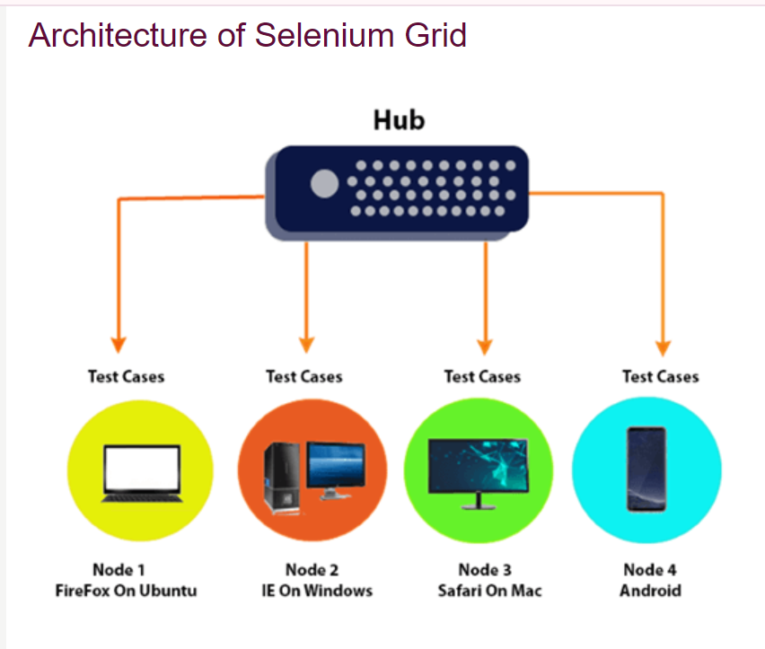

4.A Hub is a central point or a local machine that receives all the test requests and distributes them to the right nodes.

5.The machine which triggers the test case is known as Hub.

 6. There can be only one hub in a selenium grid.

7. The machine which is containing the hub triggers the test case, but we  see the browser being automated on other machines

|  |  |  |
| --- | --- | --- |
| **S.NO** | **SELENIUM IDE** | **SELENIUM WEBDRIVER** |
| **01** | It has the record and playback feature. | It does not have a record and playback |
| **02** | It requires no server to start execution of test cases. | It requires no server to start execution of test cases. |
| **03** | It can be used for testing only in Firefox. | It can be used for testing in the majority of browsers. |
| **04** | It is based on Selenese which is a procedural language. | It is majorly used for object oriented programming. |
| **05** | Elements cannot be identified. | Elements can be identified. |
| **06** | Cannot handle alerts. | Can handle alerts. |
| **07** | Cannot handle mouse actions | Can handle mouse actions |
| **08** | Cannot handle dropdown. | Can handle dropdown. |
| **09** | Cannot perform iPhone/Android testing. | Can perform iPhone/Android testing. |
| **10** | Does not have a Listener. | Has a Listener. |
| **11** | Derived from Javascript. | Not derived from Javascript. |
| **12** | Only has absolute xpath. | It has both relative and absolute xpath. |
| **13** | Cannot handle navigation. | Can handle navigation. |

**5.STEPS TO CREATE A SIMPLE WEB DRIVER SCRIPT:**

Set up a Java Integrated Development Environment (IDE) like EclipsE.

Copy the dependency of webdriver manager and Selenium .

Add  to the pom.xml file and the dependencies will be added in Maven Dependencies.

**Create a New Maven Project:**

* Open your IDE and create a new Java project.

Create a package inside the java project.

Create a class with a name and write the script for it.

* Create a new Java class in a package.
* Open the browser and launch the Url.
* Set the driver and add the Url.
* Write the script for Selenium WebDriver and Chrome driver to interact with a web page.

**Code (Output for the given code is attached in Q.No:2)**

**package** task13;

**import** org. openqa.selenium.By;

**import** org.openqa.selenium.Keys;

**import** org.openqa.selenium.chrome.ChromeDriver;

**public** **class** Browser {

**public** **static** **void** main(String[] args)

{

      // open the browser and launch the google url

//set the driver

ChromeDriver driver=**new** ChromeDriver();

  // add the Url

driver.get("https://www.google.com/");

// maximize the driver

driver.manage().window().maximize();

//locate the element

driver.findElement(By.*name*("csi")).sendKeys("Selenium Browser Driver",Keys.***ENTER***);

// close the browser

driver.close();

}

}

**2.OUTPUT FOR SELENIUM SCRIPT IN JAVA TO OPEN GOOGLE AND SEARCH FOR “SELENIUM BROWSER DRIVER”.**

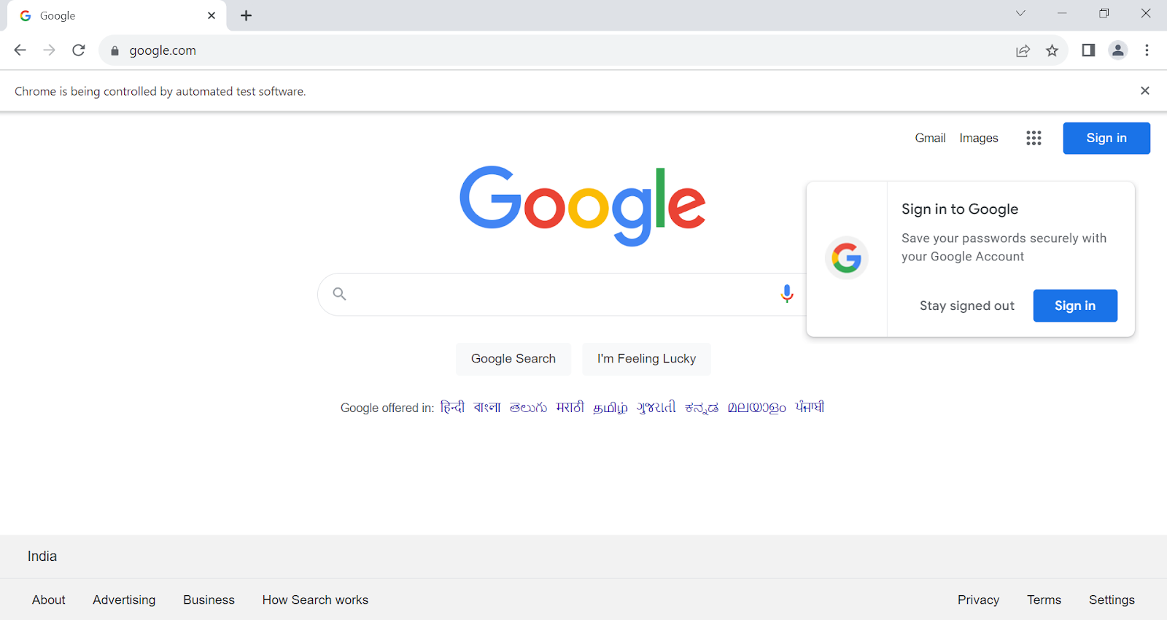

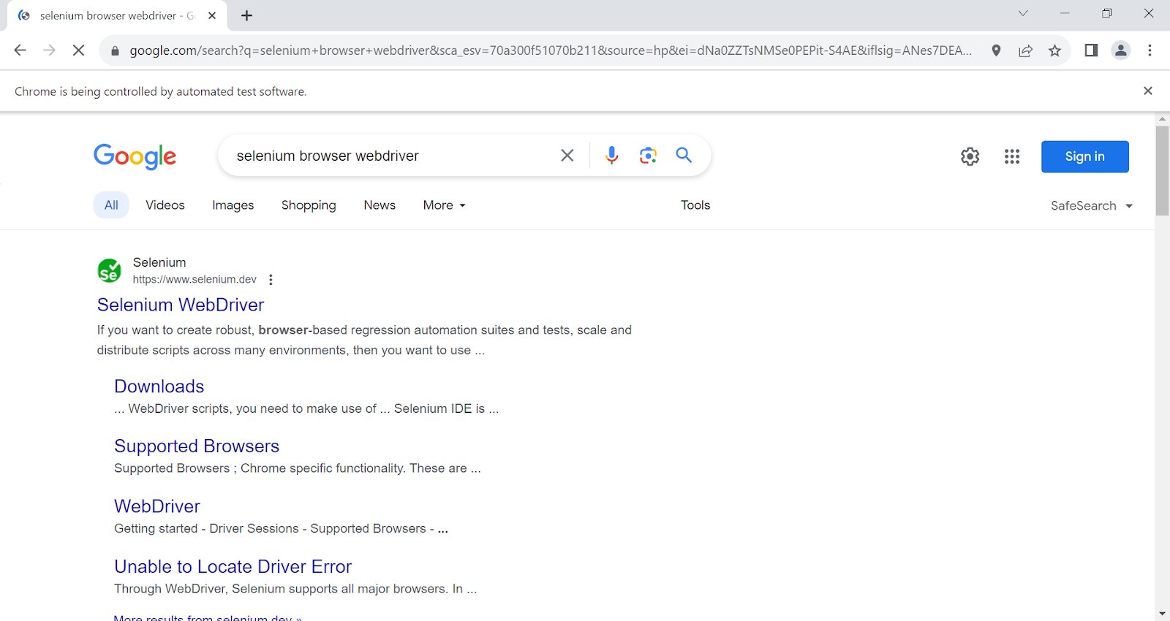

**3. SELENIUM AND IT’S USE IN AUTOMATION TESTING:**

**SELENIUM:**

Selenium is one of the most widely used open source Web UI (User Interface) automation testing suite.It was  developed by Jason Huggins in 2004 as an internal tool at Thought Works. Selenium supports automation across different browsers, platforms and programming languages.

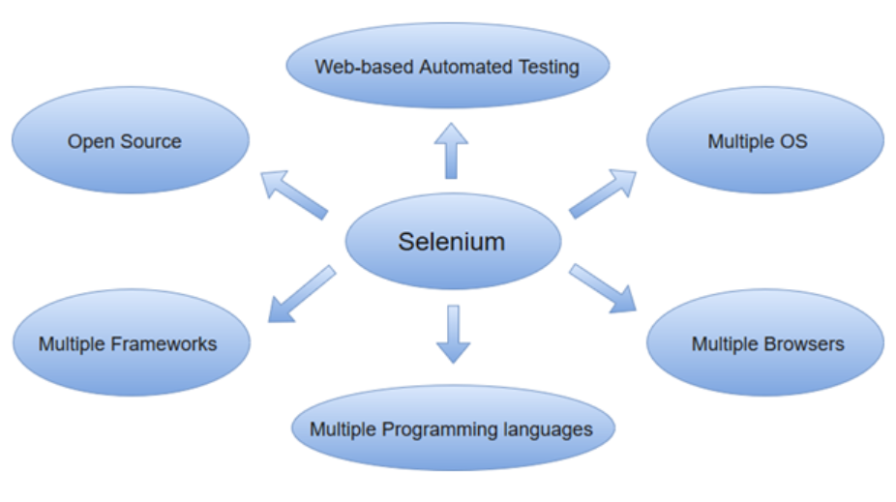

**Reasons are given below to show how it is helpful in automation testing:**

**1. Language and Framework Support**

Selenium supports all major languages like Java, Python, JavaScript, C#, Ruby, and Perl programming languages for software test automation.

Selenium supported language has frameworks which help in writing test scripts for Selenium test automation. So, when we use the Selenium tool no need to worry about language and framework.

**2. Open Source Availability**

Selenium is a publicly accessible automation framework and is free.

 It also helps you customize the code for better code management and enhance the functionality .

**3. Multi-Browser Support**

Chrome, Firefox, Safari, Internet Explorer, Opera, and Edge browsers are the most used browsers worldwide and Selenium script is compatible with all browsers.

No need to rewrite scripts for every browser.

**4. Support Across Various Operating Systems**

 Selenium is a portable tool that supports and can work across different operating systems like Windows, Linux, Mac OS, UNIX, etc.

**5. Ease Of Implementation**

Selenium automation framework is a very easy-to-use tool.

It provides a user-friendly interface that helps create and execute test scripts easily and effectively.

**6. Reusability and Integrations**

Its suite is reusable and can be tested across multiple browsers and operating systems. t Selenium is not an all-inclusive web automation testing tool and it needs third-party frameworks and add-ons to broaden the scope of testing.

For example, We need to integrate Selenium with [TestNG](https://testng.org/) and [JUnit](https://junit.org/junit5/) for managing test cases and generating reports.

**7. Flexibility**

It becomes easier and more efficient with Selenium features like regrouping and refactoring of test cases.

It helps developers and testers alot.

These features make Selenium more flexible and usable .

**8. Parallel Test Execution and Faster Go-to-Market**

The main aim of automated testing is to save time.

Selenium Grid, helps to execute multiple tests in parallel, hence reducing the test execution time.

**9. Less Hardware Usage**

Selenium requires less hardware as compared to other testing tools.

**10. Easy to Learn and Use**

Selenium scripts are not something like writing a hundred-page complex algorithm.

It's very simple to learn and use.

**4.BROWSER DRIVERS USED IN SELENIUM:**

**Selenium WebDriver interacts with web browsers through browser-specific drivers. Each browser has its own driver, and Selenium supports a variety of browsers.**

The following are the different types of drivers available in Selenium WebDriver:

**ChromeDriver-**It is used for executing Selenium Automation Scripts on Chrome Browser.

**FirefoxDriver-**It is used for executing Selenium Automation Scripts on Firefox Browser.

**InternetExplorerDriver-**It is used for executing Selenium Automation Scripts on Internet Explorer Browser.

**SafariDriver-**It is used for executing Selenium Automation Scripts on Safari Browser.

**OperaDriver-**It is used for executing Selenium Automation Scripts on Opera Browser.

**EdgeDriver-**It is used for executing Selenium Automation Scripts on Edge Browser

**EventFiringWebDriver-**It is used for firing the WebDriver listener events

**RemoteWebDriver-**It is used with Selenium Grid for executing automation scripts on different remote machines